**Assumptions:**

Backend service is running on <http://localhost:9000> and cross origin access enabled for this

URL :( http://localhost:4200)

**Running the Client Application**

**Perquisite:**

Please make sure latest Node JS and Angular CLI version has been installed to your local machine. (Refer version information)

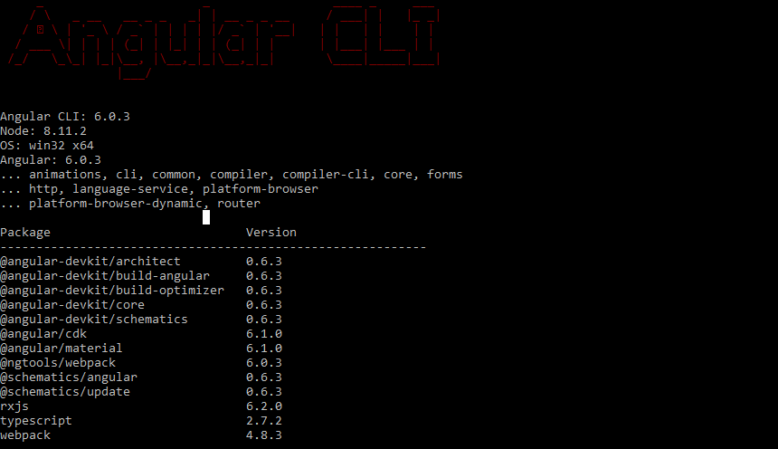

Step2: Unzip *client-machine-simulator-master.zip*

Step 3: Go to the folder and execute following commands

**npm install**

**ng serve**

You'll find the Client Application running on: <http://localhost:4200>

You can see following screens

**Contents Screen**

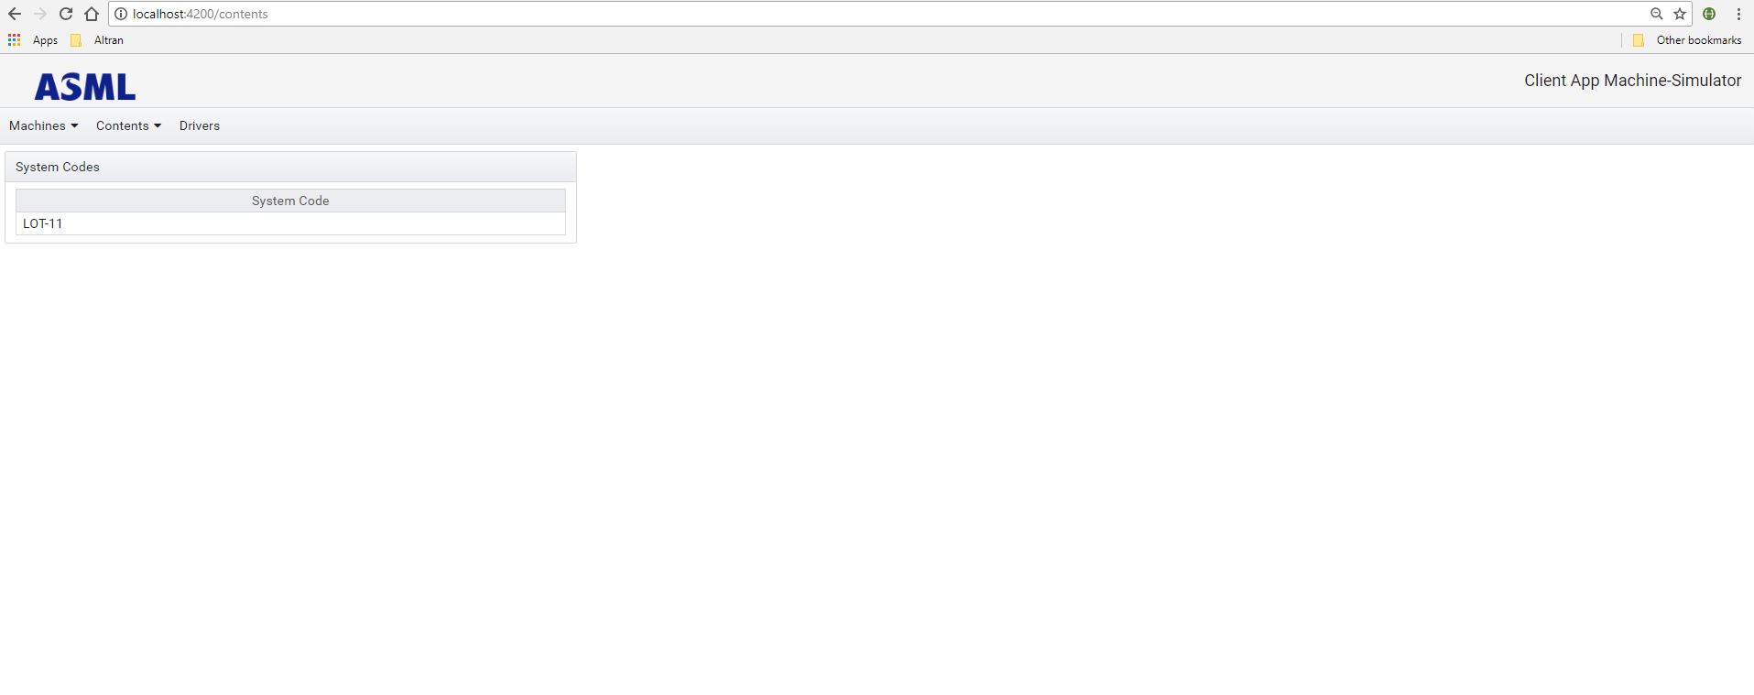

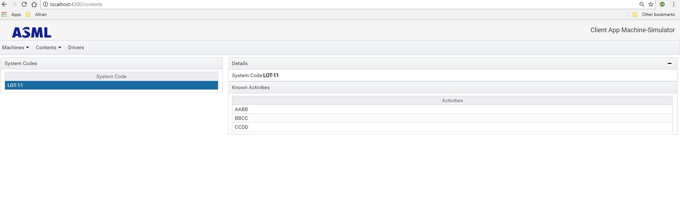

**Machines Screen:**

Has following features:

1. View Machines
2. View log entry
3. Refresh logs (Click this button to retrieve latest logs.) However yet to implement Auto refresh logs)
4. Click on the log entry to see associated system code and known activities to be performed.
5. In the Activities panel, an activity can be run on the system.

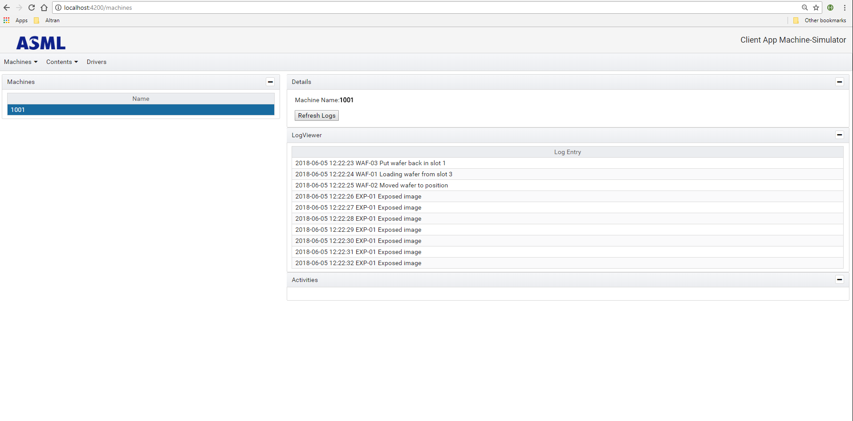

**Drivers Screen:**

Has following features:

1. Set delay
2. Reset All

